**TimeEscort Design.**

GOAL: Setup a game mode where the player must Escort and AI that must walk along a designated path, from point A to point B. In addition, the Escort Asset will be able to lose health and result on a defeat for the player. If the Escort Asset reaches point B, the player wins.

Key Features:

* **Payload:** Main asset that the player needs to escort and defend from enemies. The player has to be close for the Payload to advance to the different waypoints.
* **Waypoints**: The directions for the payload, placed in the map to create a path.
* **EnemySpawn:** Where the enemies will be spawning from.
* **Enemies:** Characters possessed by an AI, designated to approach the Payload and shoot at it to destroy it.

**How did I develop this game mode?**

I started creating a map, I imagined where would be the best place to put walls and to create the path, the reason behind t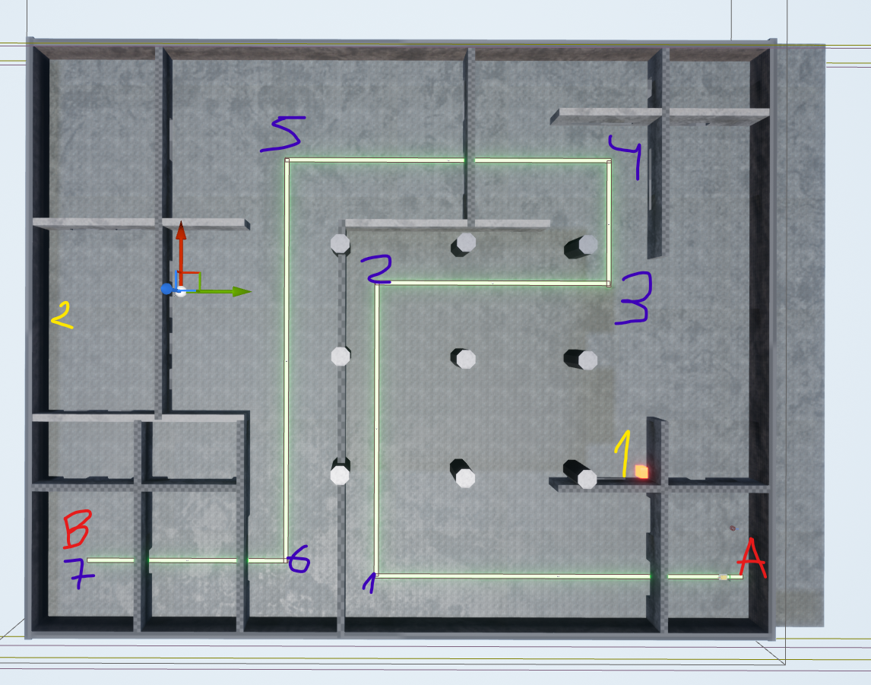he map.

**Legend:** A and B red are the start and the victory for the player. On blue will find the position of each Waypoint. The yellow numbers are the position of the Enemy Spawn portals.

First when we look at the map we start with a small room, where the player will be able to start moving the payload, without any enemy bothering him for the first 30 – 40 seconds. After the player gets out of the first doorway with the payload enemies will start appearing from the back and the front. With that big open area, the player can get used to the enemies, and be able to defend the payload until it reaches the Waypoint 3 (marked in blue). Once the payload has reached this waypoint the Enemy Spawn will be placed on the Yellow 2 position, where the enemy will come from where the payload is headed. Between Waypoint 5 and 6, depending on the position of the payload, the enemies will be using different waypoints, giving the player a challenge killing all those enemies.

On the second part the mechanics of the game mode are simple. If the player is closer enough to the payload, the payload will be moving, as soon as the player moves from the range of the payload, this will stop. This way the player must be close to the payload all the time, waiting for the enemies to come at it.

For the sake of this test, the enemies only attack the payload, so there is no health or damage to the player.

The enemies have 100 of health and each Player bullets will rest 25, making each enemy be killed by 4 bullets.

As most of the times the player will not be looking at the payload, I have added movement feedback on the UI. If the payload is moving a message “Moving the payload!” will be appearing in the screen.

The Payload has 100 of health and each enemy bullet will remove 10, allowing the Payload to suffer 10 hits. This will be handy from Waypoint 5, where the enemies will get closer to the payload.

Assets Functions Explained:

**Payload_AI:**

1. Player Nearby, it detects if the player is close, setting a Boolean on and off to trigger the movement. 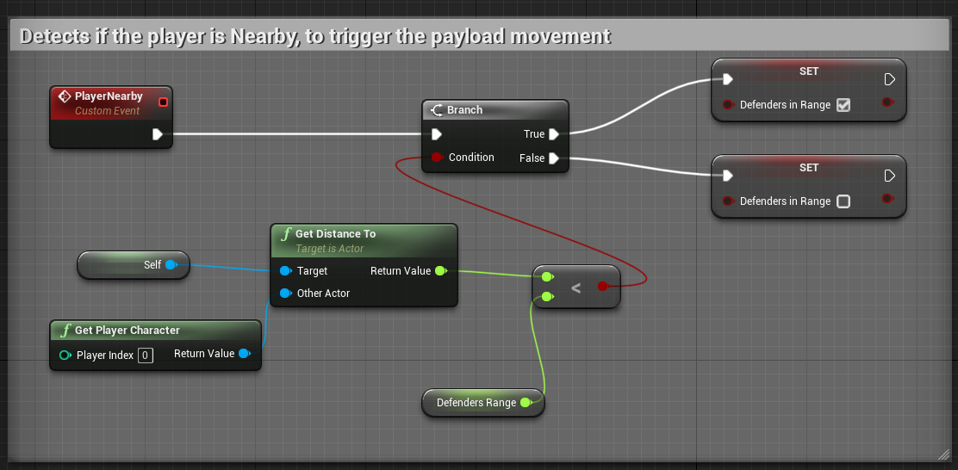
2. Payload Movement, from an array of waypoints the payload moves on the direction of the current waypoint, every time that reaches a waypoint, the current waypoint gets updated with the next waypoint in the array. As the payload is a floating actor, does not have a direction of rotation by its own, using the rotation of the waypoints, we can rotate the payload in the direction of the waypoint. 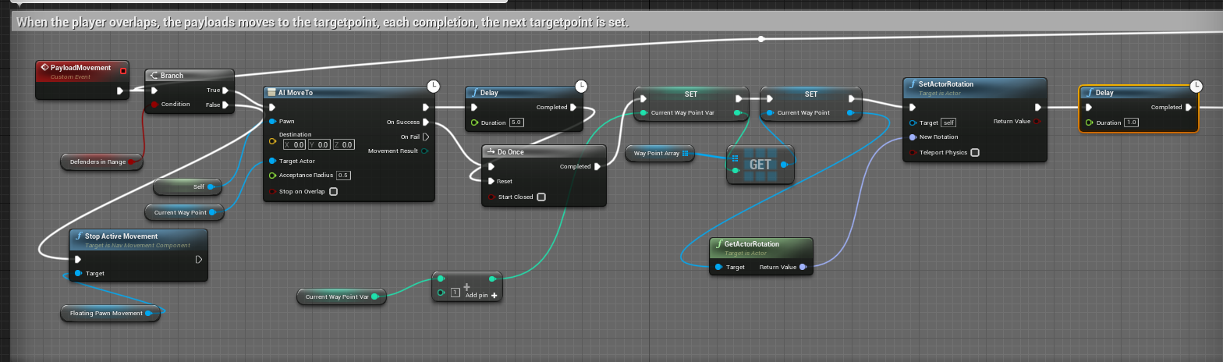
3. Payload Movement 2: if the payload reaches the 4th waypoint, the Enemy Spawn changes its location. 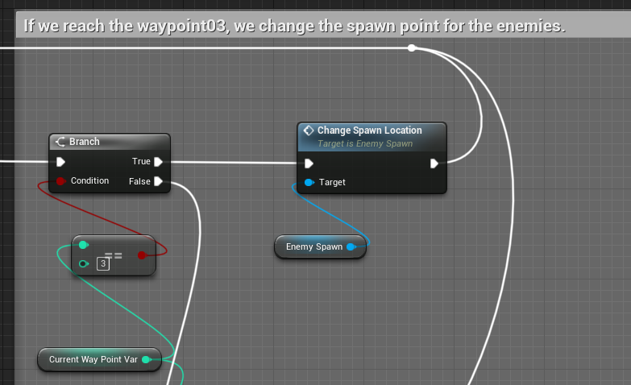
4. Payload Movement 3: if the payload reaches the last waypoint, the Player Wins the game. 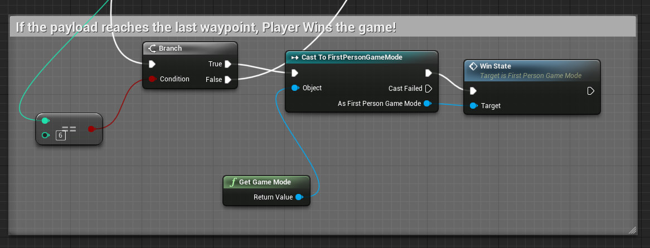
5. Payload health and damage, simple receive damage from the enemy bullets. If its life gets to 0, the game ends with a defeat. 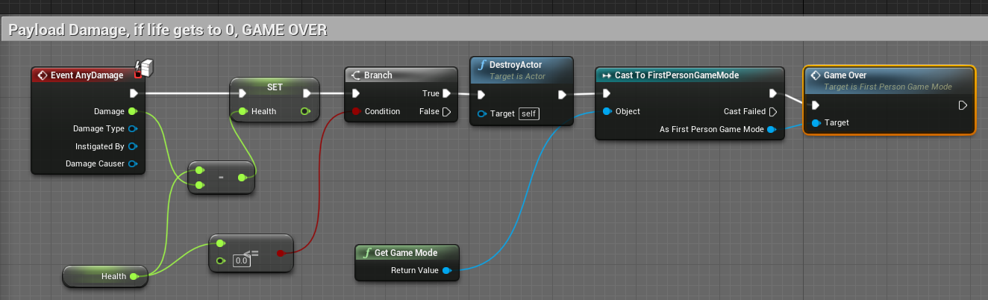

**EnemySpawn:**

1. Spawn Enemies, it spawns a new Actor from the Class Enemy, with a delay (SpawnRate). The number of enemies that will be spawned can be setup with Max Enemy Counter variable. 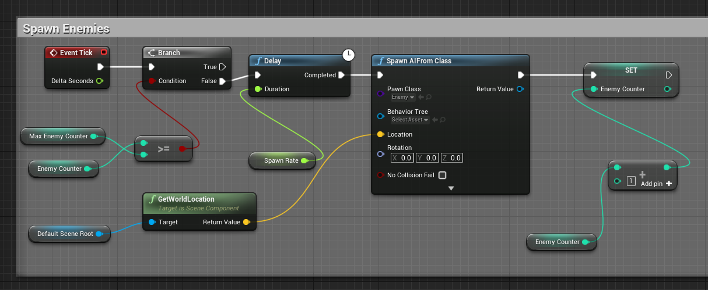
2. Change Spawn Location, it changes the location to another point in the Map. 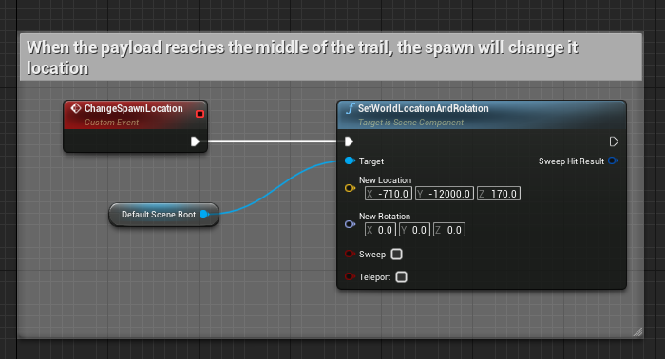

**Enemy:**

1. 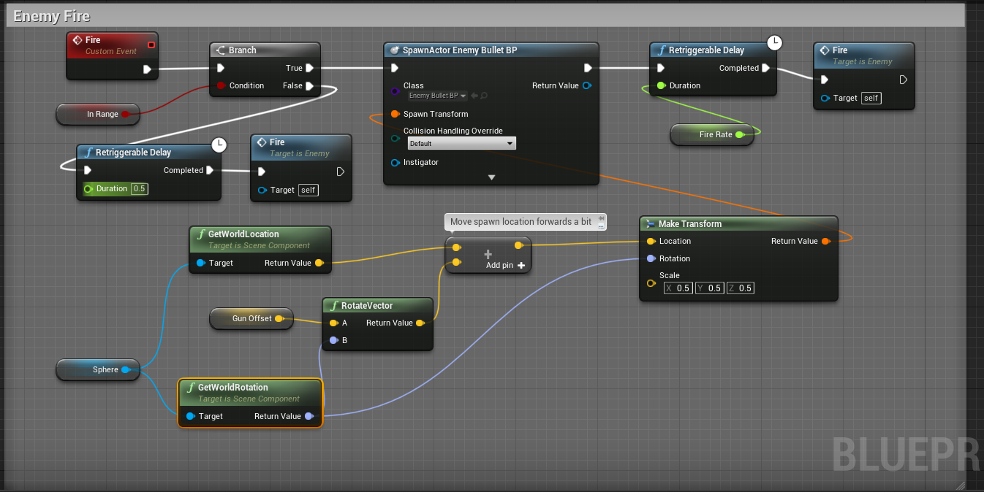Fire, this has a retriggerable delay, that will always check if the Asset in this case is the payload is in range and then shoot by spawning an enemy bullet.
2. AI go to payload, the enemy will approach the payload.
3. 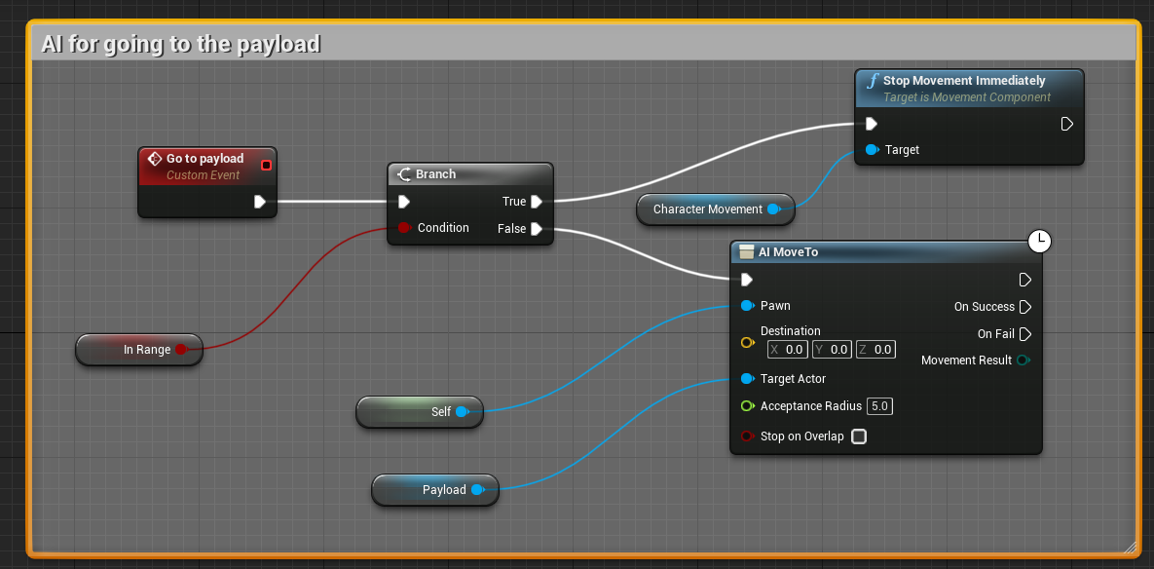Aggro Range, this is the same function used to check the if the player is close to the payload but adapted to the Enemy and the Payload.
4. 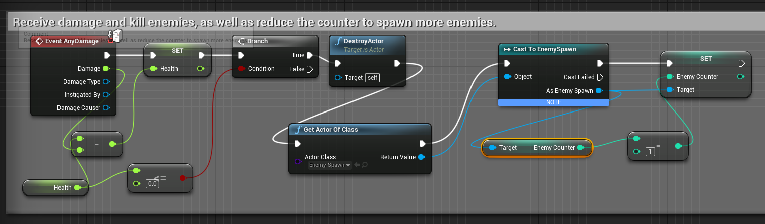Receive damage and killing the enemy, the enemy will receive damage from the player, if the enemy is killed it will remove one enemy counter from the EnemySpawn allowing the last to spawn another enemy.
5. Run all the functions, we use Event tick to direct the enemy to the payload, to check the aggro range and to get the payload asset. 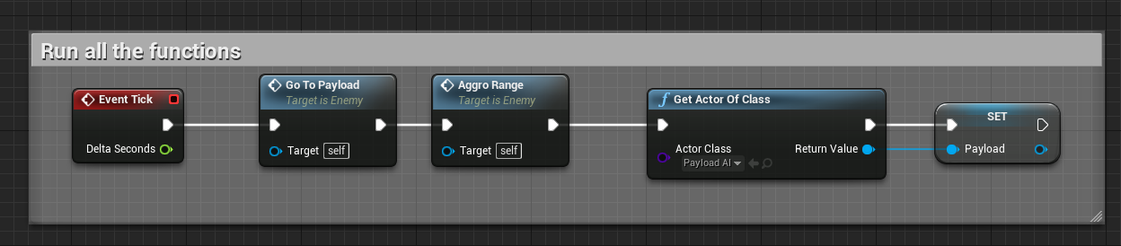

**Bullets:**

1. Cause damage and destroy the bullet:

